## Testing with Pytest

* Pytest was used to test modules in my pygame project prototype
  + This is a testing framework for Python that allows writing of simple and scalable test cases
* Tested modules included:
  + Enemy class
  + Tower class
  + Map class
* Thus thoroughly testing all core functionalities in this prototype of my tower defense game.
* When running test on map class functions, the reset map function did not work as expected.
  + 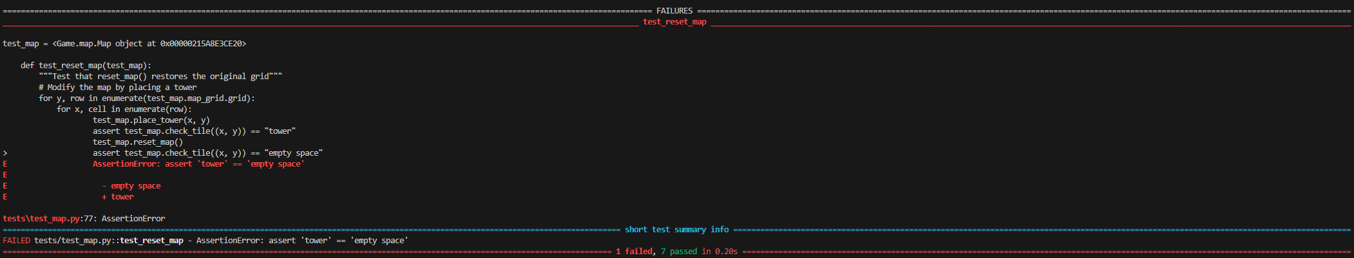Assertion error shows that the expected output (‘empty space’) differed from the actual output (‘tower’) indicating that the reset_map function did not work as intended.
  + The fix here was to use pythons deepcopy method (from Python’s copy module) to ensure that the map itself was not a stored reference to the default map/grid but rather a copy of it. (fully independent)
* Other testing ran smoothly, with no errors; all actual outputs matched the expected outputs in tested methods.



## Game prototype in Action (Core Functionality)

* 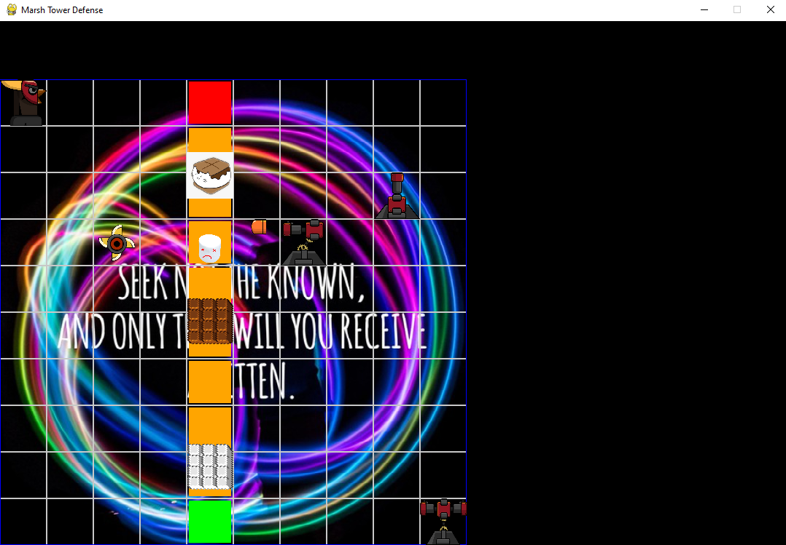Prototype currently has basic towers, enemies, and a map system involving a grid module.

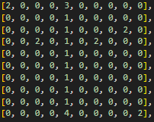

In game grid (inside grid class inside map class) at point in prototype screenshot:

* Map backdrop, path, demonstration/placeholder towers and demonstration/placeholder enemies implemented.
  + Towers rendered on map (in grid represented by number 2)
  + Closest tower is in range to shoot – currently shoots bullets consistently horizontally left.
  + Enemies spawn in at start tile (red) and move towards end goal tile (green), and being removed once they reach such tile.
  + Bullets can successfully collide with enemies, registering a hit and lowering the enemy’s health by its own damage.
* Basic path drawn based on demonstration grid
  + Orange represents basic path tile. (in grid represented by number 1)
  + Red represents start tile. (in grid represented by number 3)
  + Green represents end goal tile. (in grid represented by number 4)